**Centennial College**

**COMP 228: Java Programming**

**LAB #4 – Developing UI using JavaFx**

**Studen**t: **Aryan Patel**

**SIN: 301226774**

Due Date: **Week 9**.

Purpose: The purpose of this Lab assignment is to:

1. Practice the use of JavaFX.

References: Learning materials for weeks 7, 8, textbook, and other references (if any).

This material provides the necessary information you need to complete the exercises.

Be sure to read the following general instructions carefully:

This lab should be completed individually by all the students. You will have to demonstrate your solution in a scheduled lab session and submitting the project **through the drop box link**.

You must name your Eclipse project according to the following rule:

**YourFullName_COMP228Labnumber**

Example: **JohSmith_COMP228Lab4**

Each exercise should be placed in a separate package named *exercise1*, *exercise2*, etc.

Submit your assignment in a **zip file** that is named according to the following rule:

**YourLastName_COMP228Labnumber.zip**

Example: **JohSmith_COMP228Lab4.zip**

Apply the naming conventions for variables, methods, classes, and packages:

- *variable names* start with a *lowercase* character

- *classes* start with an *uppercase* character

- **packages** use only *lowercase* characters

- *methods* start with a *lowercase* character

## Exercise 1

Write a Java application using JavaFx which allows the user to enter student information (see the sample design below).

#### 

#### The user will enter *full* *name*, *address,* *city, province, postal code, phone number and email* in *text field* controls. The student’s *major* (Computer Science or Business) will be selected from two *radio buttons*.

#### A combo box will display the list of *courses* for each program whenever the user selects the desired program.

#### A course will be added to a *list box w*henever the user selects a course from the corresponding combo box. Make sure that the user cannot add a course several times.

Additional information about the student will be provided from a group of *check boxes* (such as involvement in various activities, etc).

All the information about the student will be displayed in a text *area* component. Use simple JavaFX layout managers, such as FlowPane, BorderPane, and GridPane to create the JavaFX GUI of this application.

(10 marks)

**package** application;

**import** javafx.application.Application;

**import** javafx.event.ActionEvent;

**import** javafx.event.EventHandler;

**import** javafx.geometry.HPos;

**import** javafx.geometry.Insets;

**import** javafx.geometry.Pos;

**import** javafx.stage.Stage;

**import** javafx.scene.Group;

**import** javafx.scene.Scene;

**import** javafx.scene.control.Button;

**import** javafx.scene.control.CheckBox;

**import** javafx.scene.control.ComboBox;

**import** javafx.scene.control.Label;

**import** javafx.scene.control.RadioButton;

**import** javafx.scene.control.TextArea;

**import** javafx.scene.control.TextField;

**import** javafx.scene.control.ToggleGroup;

**import** javafx.scene.layout.BorderPane;

**import** javafx.scene.layout.GridPane;

**import** javafx.scene.paint.Color;

**public** **class** Main **extends** Application {

**private** String[] businessManegemnt = {"Accounting", "Marketing", "Business"};

**private** String[] computerScience = {"Web Development", "Java Programing", "DataBase Management"};

**private** String selected = "";

**private** Boolean[] cEnabled = {**true**,**true**,**true**};

**private** RadioButton csButton;

**private** RadioButton BButton;

**private** ComboBox<String> cDD;

**private** TextArea scList;

@Override

**public** **void** start(Stage primaryStage) {

BorderPane pane = **new** BorderPane();

Scene scene = **new** Scene(pane, 900, 450);

primaryStage.setTitle("Exercise 2");

primaryStage.setScene(scene);

GridPane westArea = **new** GridPane();

pane.setLeft(westArea);

westArea.setAlignment(Pos.***CENTER***);

westArea.setPadding(**new** Insets(10, 10, 10, 10));

westArea.setHgap(10);

westArea.setVgap(3);

westArea.add(**new** Label("Name: "), 0, 0);

TextField nameText = **new** TextField();

westArea.add(nameText, 1, 0);

westArea.add(**new** Label("Address: "), 0, 1);

TextField addressText = **new** TextField();

westArea.add(addressText, 1, 1);

westArea.add(**new** Label("Province: "), 0, 2);

TextField provinceText = **new** TextField();

westArea.add(provinceText, 1, 2);

westArea.add(**new** Label("City: "), 0, 3);

TextField cityText = **new** TextField();

westArea.add(cityText, 1, 3);

westArea.add(**new** Label("Postal Code: "), 0, 4);

TextField postalText = **new** TextField();

westArea.add(postalText, 1, 4);

westArea.add(**new** Label("Phone Number: "), 0, 5);

TextField phoneText = **new** TextField();

westArea.add(phoneText, 1, 5);

westArea.add(**new** Label("Email Address: "), 0, 6);

TextField emailText = **new** TextField();

westArea.add(emailText, 1, 6);

GridPane centerArea = **new** GridPane();

pane.setCenter(centerArea);

centerArea.setAlignment(Pos.***CENTER***);

centerArea.setPadding(**new** Insets(10, 10, 10, 10));

centerArea.setVgap(5);

CheckBox scCheck = **new** CheckBox("Student council");

centerArea.add(scCheck, 0, 0);

CheckBox vwCheck = **new** CheckBox("Volunteer work");

centerArea.add(vwCheck, 0, 1);

GridPane eastArea = **new** GridPane();

pane.setRight(eastArea);

eastArea.setAlignment(Pos.***CENTER***);

eastArea.setPadding(**new** Insets(10,10,10,10));

eastArea.setVgap(10);

GridPane buttonArea = **new** GridPane();

buttonArea.setHgap(10);

csButton = **new** RadioButton("Computer Science");

buttonArea.add(csButton, 0, 0);

BButton = **new** RadioButton("Business");

buttonArea.add(BButton, 1, 0);

ToggleGroup radioGroup = **new** ToggleGroup();

csButton.setToggleGroup(radioGroup);

csButton.setSelected(**true**);

BButton.setToggleGroup(radioGroup);

eastArea.add(buttonArea, 0, 0);

RadioHandler radioHandler = **new** RadioHandler();

csButton.setOnAction(radioHandler);

BButton.setOnAction(radioHandler);

scList = **new** TextArea();

scList.setPrefRowCount(5);

cDD = **new** ComboBox<>();

cDD.getItems().addAll(computerScience);

cDD.setOnAction(**new** EventHandler<ActionEvent>() {

@Override

**public** **void** handle(ActionEvent arg0) {

**int** index = cDD.getSelectionModel().getSelectedIndex();

**if**(cDD.getSelectionModel().getSelectedItem() != **null** && cEnabled[index] == **true**)

{

selected += cDD.getSelectionModel().getSelectedItem() + "\n";

scList.setText(selected);

cEnabled[index] = **false**;

}

}

});

eastArea.add(cDD, 0, 1);

eastArea.add(scList, 0, 2);

GridPane southArea = **new** GridPane();

pane.setBottom(southArea);

southArea.setAlignment(Pos.***CENTER***);

southArea.setPadding(**new** Insets(10, 10, 10, 10));

southArea.setVgap(10);

Button display = **new** Button("Display");

TextArea displayBox = **new** TextArea();

displayBox.setPrefColumnCount(75);

GridPane.*setHalignment*(display, HPos.***CENTER***);

display.setOnAction(**new** EventHandler<ActionEvent>() {

@Override

**public** **void** handle(ActionEvent arg0) {

String name = nameText.getText();

String address = addressText.getText();

String province = provinceText.getText();

String city = cityText.getText();

String postal = postalText.getText();

String phone = phoneText.getText();

String email = emailText.getText();

String displayString = String.*format*("%s,%s,%s,%s,%s,%s,%s", name,address, province, city, postal, phone, email);

String courses = "\n\nCourses: \n" + scList.getText();

displayString += courses;

**if**(scCheck.isSelected())

displayString += "\nStudent council member";

**if**(vwCheck.isSelected())

displayString += "\nVolunteer worker";

displayBox.setText(displayString);

}

});

southArea.add(display, 0, 0);

southArea.add(displayBox, 0, 1);

primaryStage.show();

}

**class** RadioHandler **implements** EventHandler<ActionEvent>

{

@Override

**public** **void** handle(ActionEvent event) {

cDD.getItems().clear();

selected = "";

scList.setText(selected);

**for** (**int** i=0; i<3; i++)

{

cEnabled[i] = **true**;

}

**if**(event.getSource() == csButton)

cDD.getItems().addAll(computerScience);

**else**

cDD.getItems().addAll(businessManegemnt);

}

}

**public** **static** **void** main(String[] args) {

*launch*(args);

}

}

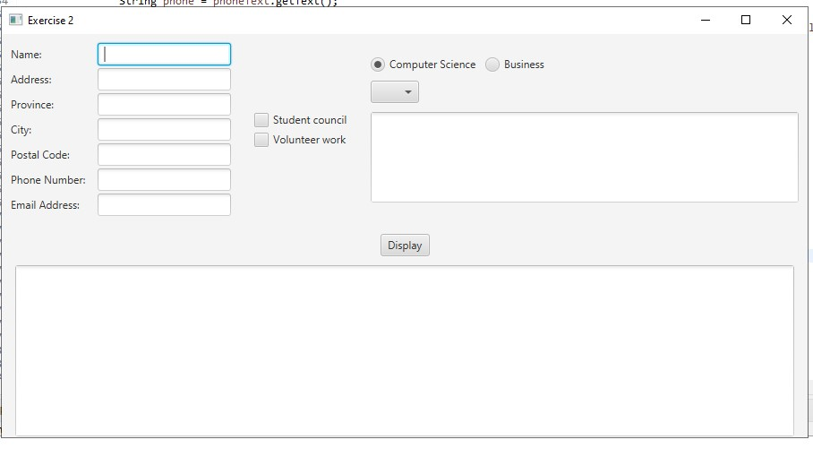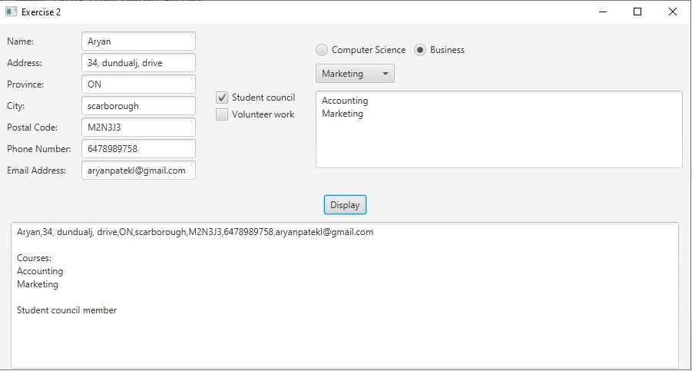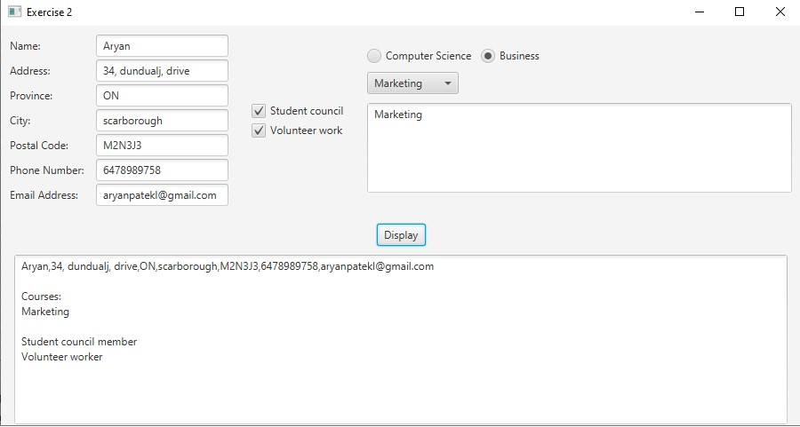

**Evaluation:**

|  |  |
| --- | --- |
| **Functionality** |  |
| Correct implementation of UI | 40% |
| Correct implementation of event handling and display of results | 40% |
| Comments, correct naming of variables, methods, classes, etc. | 5% |
| **Friendly input/output** | 15% |
| **Total** | 100% |